Chapter 18, Problem 1.

Obtain the Fourier transform of the function in Fig. 18.26.

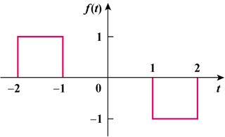

Figure 18.26
For Prob. 18.1.

